**Derivation of Linear Regression**

**1.1.1**

In simple linear regression, we aim to fit a line to a set of data points. The model is defined as :

In univariate linear regression, we model the relationship between a single input feature x and an output y using a simple equation.

The function of theta of x equals w times x plus b, where w is the weight and b is the bias.

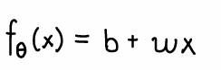

Here are this with some data points and our linear model.

To find the optimal values for w and b, we need a loss function that measures how well our model fits the data. We typically use Mean Squared Error.

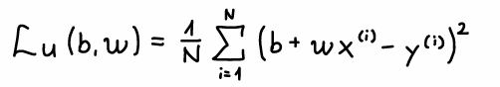

This can be expanded by substituting our model equation, giving us the loss as a function of w and b.

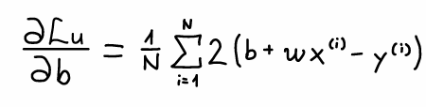

To find the optimal value of w, we need to compute the partial derivative of the loss function with respect to w.

We start by applying the derivative to our expanded loss function.

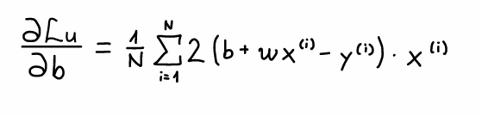

We can move the derivative inside the summation.

Using the chain rule, we first calculate the derivative of the squared term.

Next, we calculate the derivative of the inner term with respect to w, which gives us x_i.

Finally, we simplify to get our derivative of the loss function with respect to w.

Let's visualize how this derivative helps us find the optimal weight.

The derivative tells us the direction and magnitude to adjust w to decrease the loss. This is the essence of gradient descent.

At the minimum of the loss function, the derivative equals zero. This is where the optimal value of w is found.

Now we need to derive the derivative of the loss function with respect to b, which is the bias term in our linear regression model.

To find the optimal bias b, we need to compute the derivative of the loss function with respect to b.

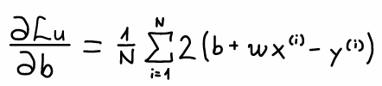

First, we bring the derivative operator inside the summation.

Next, we apply the chain rule. The derivative of the squared term gives us two times the inner expression, multiplied by the derivative of the inner expression with respect to b.

The derivative of w x_i plus b minus y_i with respect to b is simply 1, since b has a coefficient of 1 and the other terms don't involve b.

This simplifies to two over n times the sum of w x_i plus b minus y_i.

Notice that this derivative is similar to the one for w, but without the x_i term. This is because b is a constant term that equally affects all predictions, while w is multiplied by features.

The key difference is this x_i term in the derivative with respect to w, which isn't present in the derivative with respect to b.

To find the optimal bias, we set the derivative equal to zero and solve for b.

This gives us the equation two over n times the sum of w x_i plus b minus y_i equals zero.

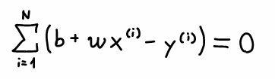

We can simplify by removing the two over n factor.

Distributing the summation to each term...

We can pull w outside the first sum, and note that the sum of b is just n times b.

Solving for b, we get that the optimal bias equals the mean of y minus w times the mean of x.

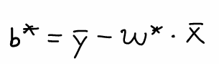

In practice, we often use gradient descent to find the optimal values of w and b iteratively.

We derive the equations by setting the sum of the gradients of the loss function with respect to the parameters to zero. This leads to the following identity :

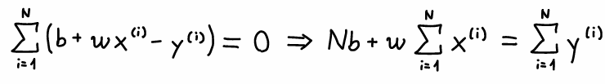  
  
Rewriting the equation of the regresssion line with mean values :

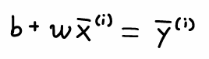

Where x bar is the mean of all x_i and y bar is the mean of all y_i :

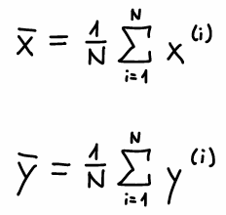

From the above , solving for b gives :

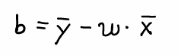

To compute the optimal slope w*, we use the following formula derived from minimizing the cost function :

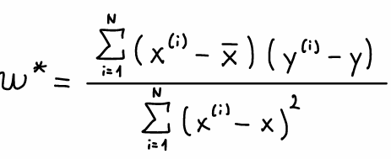

Finally , we recompute the bias using the optimal w :

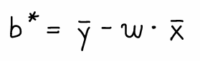

**Derivation of Linear Regression**

**1.1.2**

Selected Variable Pairs with Meaningful Linear Relationships

1. exercise_duration → calories_burned Parameter vector: θ∗=[46.2387, 5.2211]

MSE: LU(θ∗)=21843.03

Pearson correlation coefficient: r=0.8690

1. exercise_intensity → calories_burned Parameter vector: θ∗=[144.2855, 786.5502]

MSE: LU(θ∗)=27311.77

Pearson correlation coefficient: r=0.8330

1. fitness_level → max_pulse Parameter vector: θ∗=[132.5193, −0.1361]

MSE: LU(θ∗)=298.63

Pearson correlation coefficient: r=−0.0123

**Derivation of Linear Regression**

**1.1.3**

Selected Uncorrelated Variable Pairs

1. hours_sleep → average_pulseParameter vector: θ∗=[107.6003, −0.0957]

MSE: LU(θ∗)=253.51

Pearson correlation coefficient: r=−0.0035

1. hours_work → fitness_level Parameter vector: θ∗=[2.8304, −0.0829]

MSE: LU(θ∗)=2.33

Pearson correlation coefficient: r=−0.1965

1. average_pulse → calories_burned Parameter vector: θ∗=[578.3271, −1.5712]

MSE: LU(θ∗)=88581.30

Pearson correlation coefficient: r=−0.0838

1.1.4: Interpretation of Scatter Plots and the Pearson Correlation Coefficient

1. Scatter Plot Commentary

The scatter plots reveal the nature of the relationship between each variable pair:

Correlated Pairs (e.g., exercise_duration → calories_burned):  
 Points form a clear upward trend.  
 The fitted line aligns well with the data.  
 Indicates a strong positive linear relationship.  
  
Uncorrelated Pairs (e.g., hours_sleep → average_pulse):  
 Data points appear scattered without any obvious trend.  
 The fitted line often does not reflect the pattern.  
 Indicates little to no linear relationship.

These visual patterns help validate the strength and direction of linear relationships beyond numeric metrics.

1. Pearson Correlation Coefficient (r)

Range of Values: −1≤r≤1

|  |  |
| --- | --- |
| Value of **r** | Interpretation |
| r = 1 | Prefect **positive** linear correlation |
| 0 < r < 1 | **Positive** linear relationship |
| r = 0 | **No** linear correlation |
| -1 < r <0 | **Negative** linear relationship |
| r = -1 | Prefect **negative** linear correlation |

The closer **∣r∣∣r∣** is to **1**, the stronger the linear relationship.

**-A** value near **0** indicates weak or no linear dependence, even if some nonlinear pattern exists.

Example Interpretations from Our Results:

A value like r=0.8690(e.g., duration vs calories) suggests a strong positive linear relationship — the longer the exercise duration, the more calories are burned.  
  
 A value like r=−0.0035 (e.g., hours_sleep vs avg_pulse) suggests almost no linear relationship — changes in sleep hours do not meaningfully affect pulse rate.

Thus, the Pearson coefficient is a valuable summary that complements the scatter plot confirming visually observed patterns with a precise numerical value.

1.1.5:

Can a Small Positive Slope Result in a High Pearson Correlation Coefficient?

No, if the slope **w∗w∗** is very small (close to zero), the Pearson correlation coefficient **rr** cannot be close to 1. This is because:

-The slope **w∗w∗** in the linear model represents the strength of the influence of **x** on **y**.

-A small slope means that as **x** changes, **y** barely changes, suggesting little to no linear relationship.

-In contrast, the Pearson correlation coefficient **rr** measures how well the data follows a linear trend.

A value of **r≈1r≈1** indicates a strong, consistent, positive linear relationship

— one that would manifest as a steep upward slope in the data.

A near-zero slope implies a flat regression line, indicating little relationship between the variables. Therefore, it is not possible for the Pearson correlation coefficient to be close to 1 in this scenario

**Deriving the Multiple Linear Regression Solution**

**1.2.1:**

In multiple linear regression, the model is defined as: **θ (x)=b+w1 x1 +w2 x2 +⋯+wD xD**

where:

**θ=(b, w1 , w2 , …, wD )⊤∈RD+1**

**x′=(1, x1 , x2 , …, xD )⊤∈RD+1**

We are given NN data points:

**D={(x(1),y(1)), …, (x(N),y(N))}**

**where each x(i)∈RD, and y(i)∈R**.

Definition and Dimensions of the Design Matrix X:

We define the matrix **X** **ε** **RN×(D+1)** as :

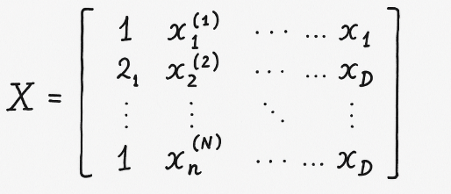

That is :

Xi1 = 1 , Xi(j+1) = xj(i)  , for i = 1,...., N, j =1 ,.... D

Dimension of X :

**X** **ε** **RN×(D+1)**

Target vector :

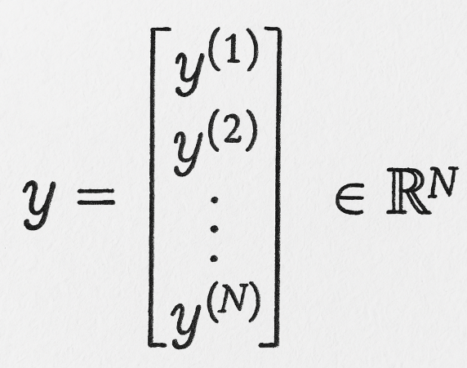

We define the multiple regression loss :

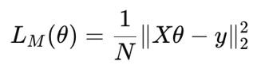

This matches the univariate case when D=1D=1, because then X∈RN×2X∈RN×2, and we get the same structure as in Task 1.1

Derivation of θ∗θ∗ Using Matrix Calculus:

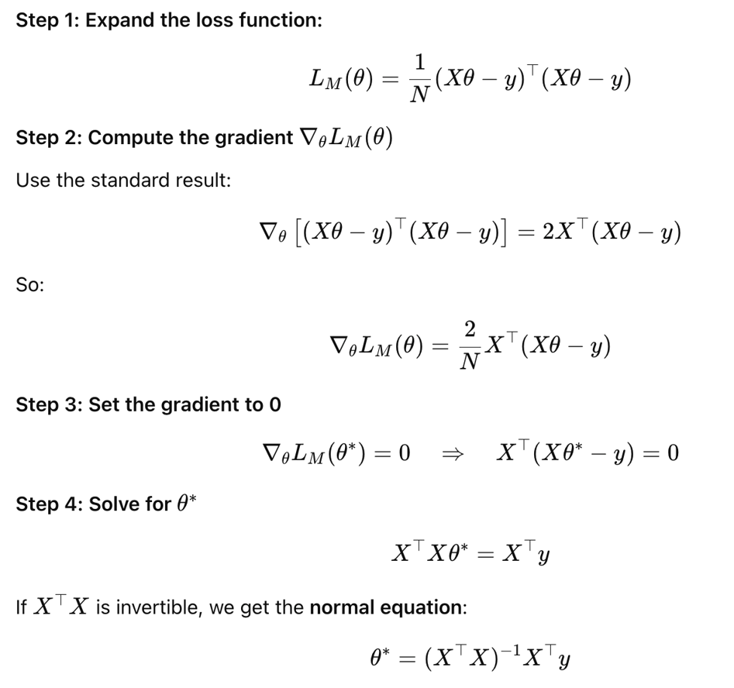

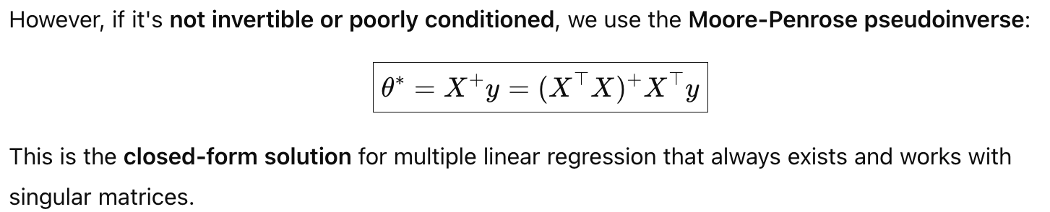

Multiple Linear Regression on Smartwatch Data:

1.2.3:

Using the implemented function fit_multiple_lin_model, the model returns the optimal parameter vector: θM∗ =[49.8088, 3.3669, 371.6853]

Intercept (bias): 49.8088 -Weight for exercise_duration: 3.3669 -Weight for exercise_intensity: 371.6853

**The final model equation is:**

fθM∗ (x)=49.8088+3.3669⋅x1 +371.6853⋅x2

**Multiple Linear Regression MSE:**

LM (θM∗ )=16517.21

**Univariate Regression MSE (from Task 1.1):**

**Using exercise_duration alone:**

LU (θU∗ )=21843.03

The multiple linear regression model achieved a lower MSE compared to the univariate model.

This confirms that using more relevant features improves predictive accuracy by capturing more variance in the target variable.

**Formal Mathematical Proof**

**1.2.4:**

The least squares solution minimizes the squared distance between yy and the column space of the design matrix. Let: CU =Col(XU )⊆RN: the space of all predictions by the univariate model .

CM =Col(XM )⊆RN: the space of all predictions by the multivariate model

Because:

XU is a submatrix of XMXM (using fewer features), and

Both matrices contain the same bias column,

**We have: CU ⊆CM**

all predictions the univariate model can make also lie within the space that the multivariate model can access — but not vice versa.

**From linear algebra:**

If CU⊆CMCU ⊆CM , then the orthogonal projection of yy onto CMCM is closer to yy than the projection onto CUCU .

Formally:

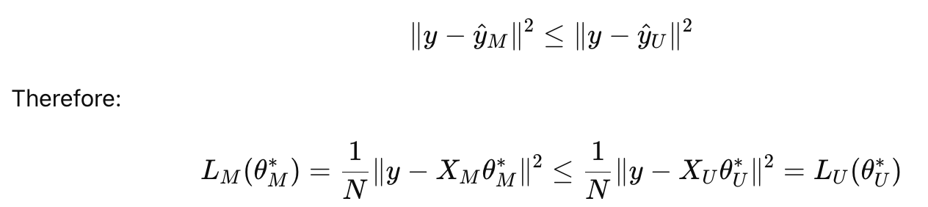

**Design Matrix for Polynomial Regression**

**1.3.1:**

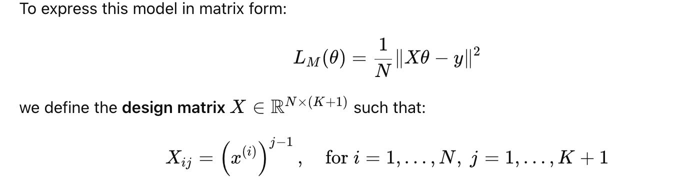

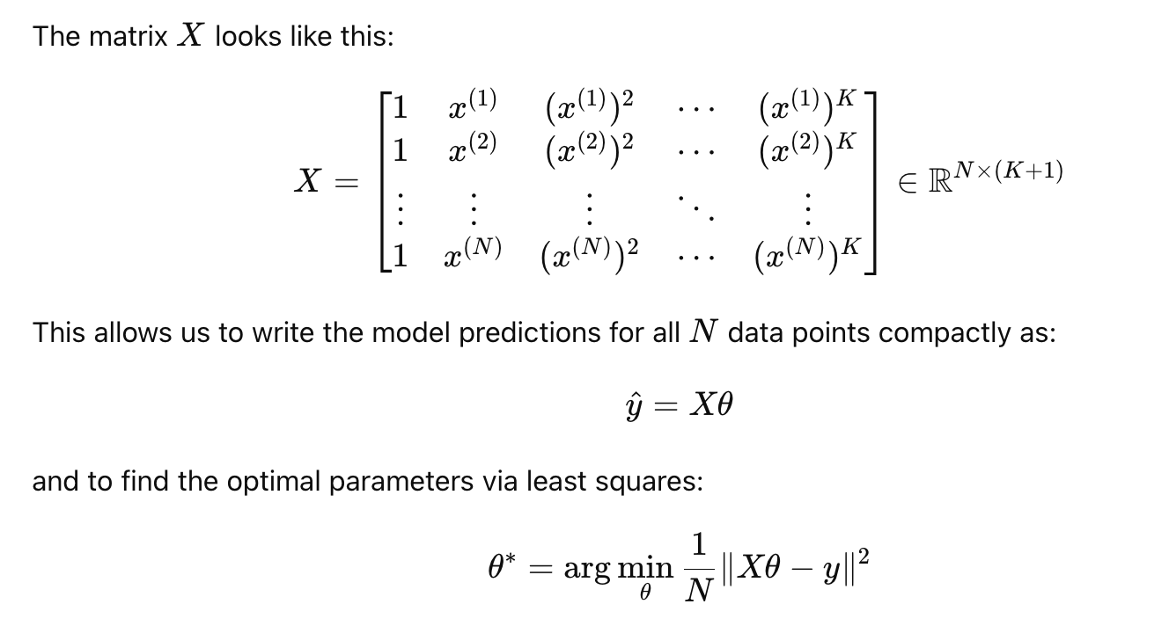

Polynomial Regression for Improved Fit

1.3.2 :

We revisit the variable pair exercise_duration → calories_burned from Task 1.1, which showed a strong linear correlation (Pearson r=0.8690r=0.8690). To improve the model fit, we now apply polynomial regression of degree K>1K>1.

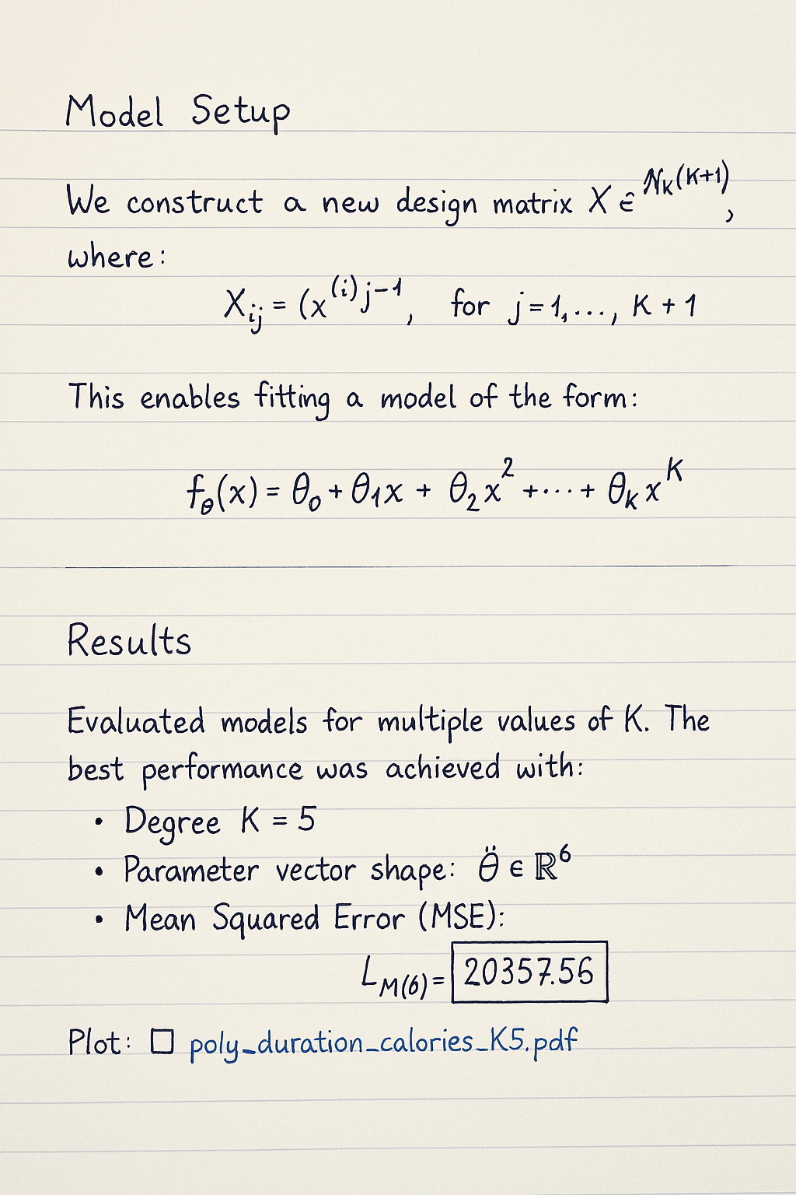

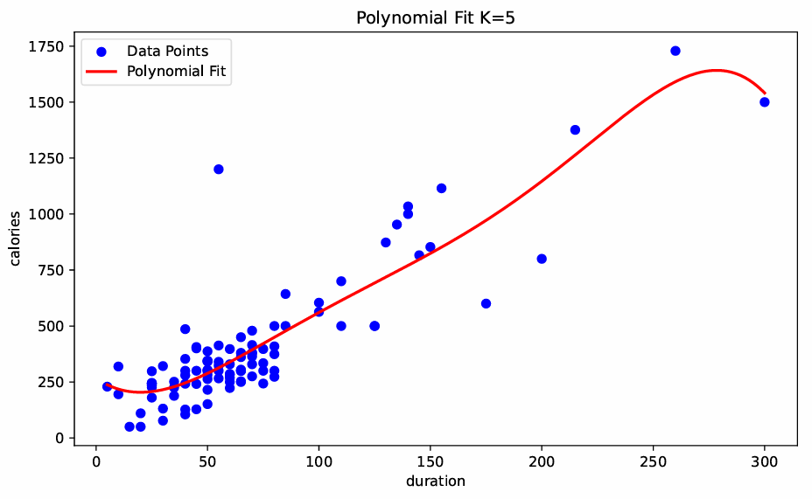

**Comparison with Univariate Linear Regression**

**From Task 1.1 (linear regression with K=1):**

Model: fθ(x)=46.2387+5.2211x

MSE: LU(θ∗)=21843.03

The polynomial model of degree 5 significantly improves the fit over the univariate linear model, reducing the MSE from 21843.03 to 20357.56. The polynomial curve also better captures the nonlinear trend visible in the data.

**Polynomial Regression with Perfect Fit (Small Dataset)**

**1.3.3:**

By incrementally increasing the polynomial degree K, we observe that:

The smallest value of K that gives zero loss is:

**K=4**

For K=4, the model interpolates all 5 data points exactly.

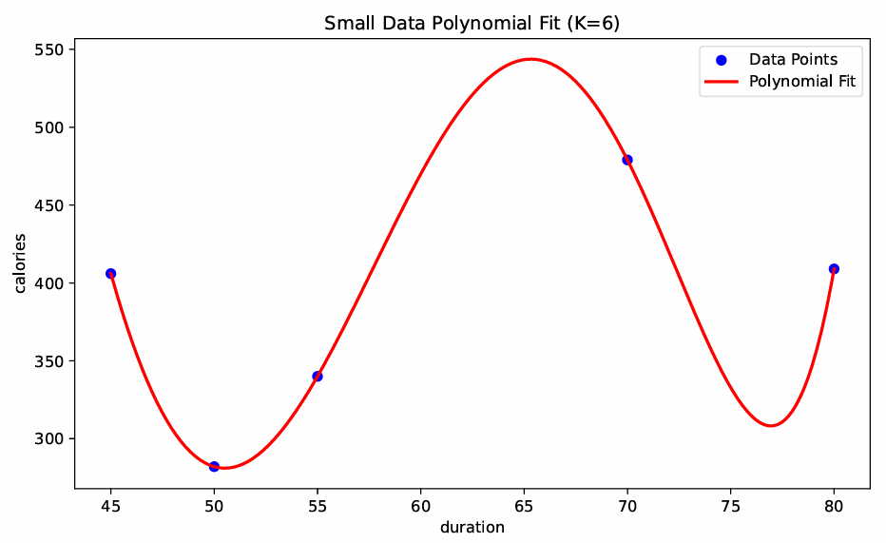

To achieve zero loss, the system must satisfy:

**Xθ∗=y**

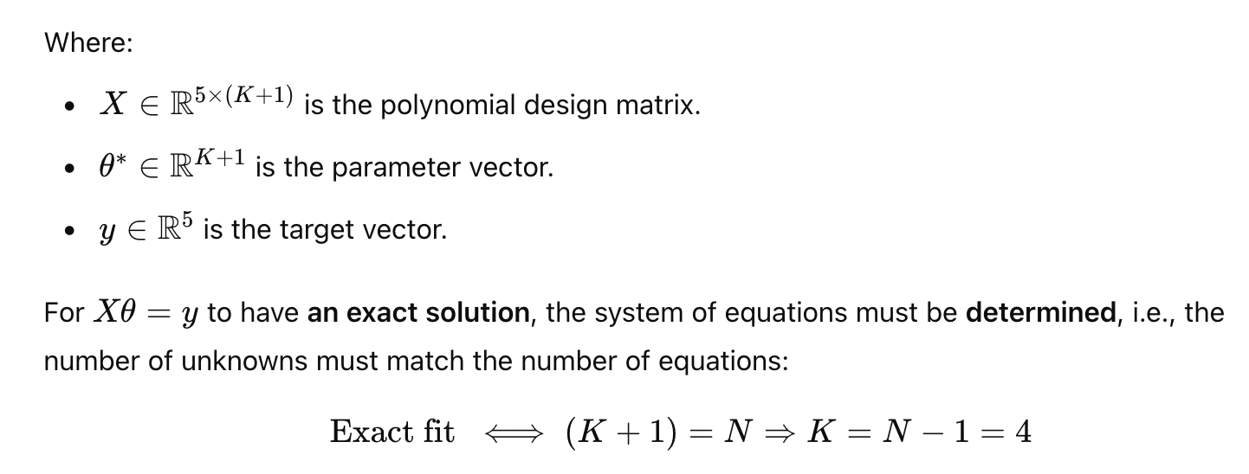

This result aligns with the theory of polynomial interpolation:

A polynomial of degree K=N−1 can perfectly interpolate N distinct data points.

**Logistic Regression – Design Matrix Setup**

**2.1:**

For this task, we used three binary classification datasets. Each dataset contains input features and binary targets (0 or 1). We used scikit-learn’s LogisticRegression model, which automatically includes a bias (intercept) term, so we did not manually add a column of ones to the design matrices.

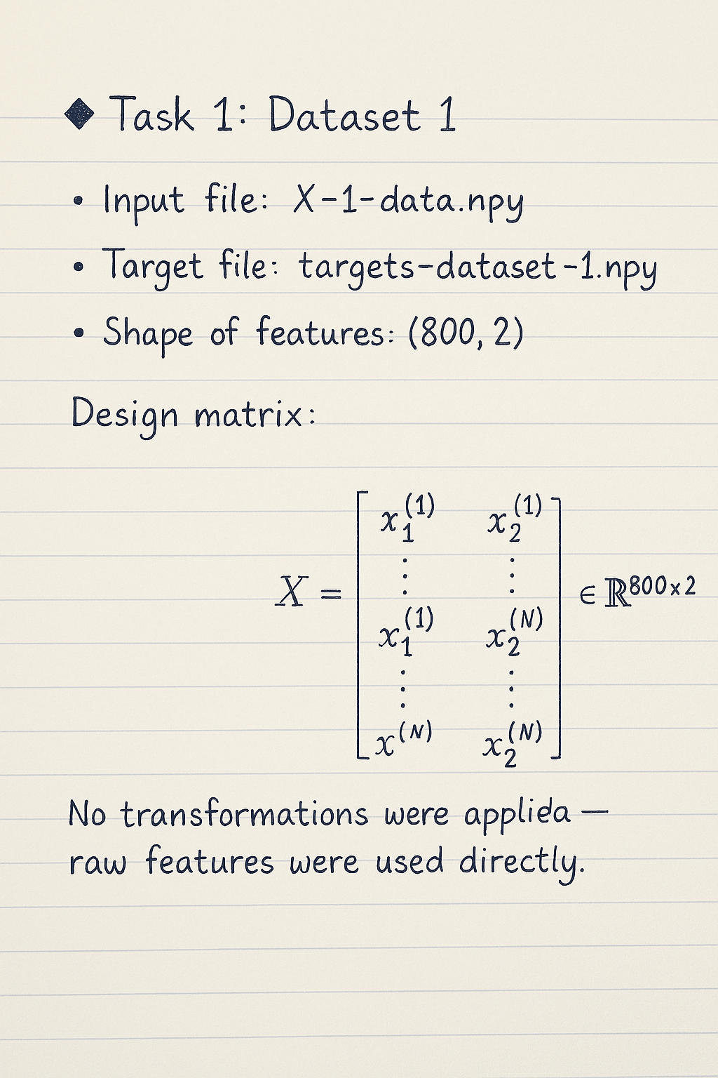

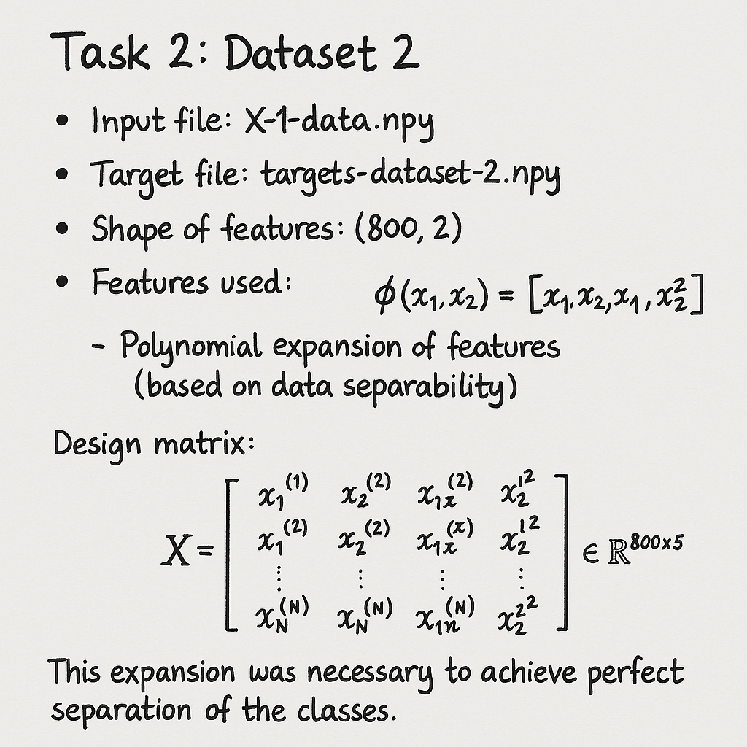

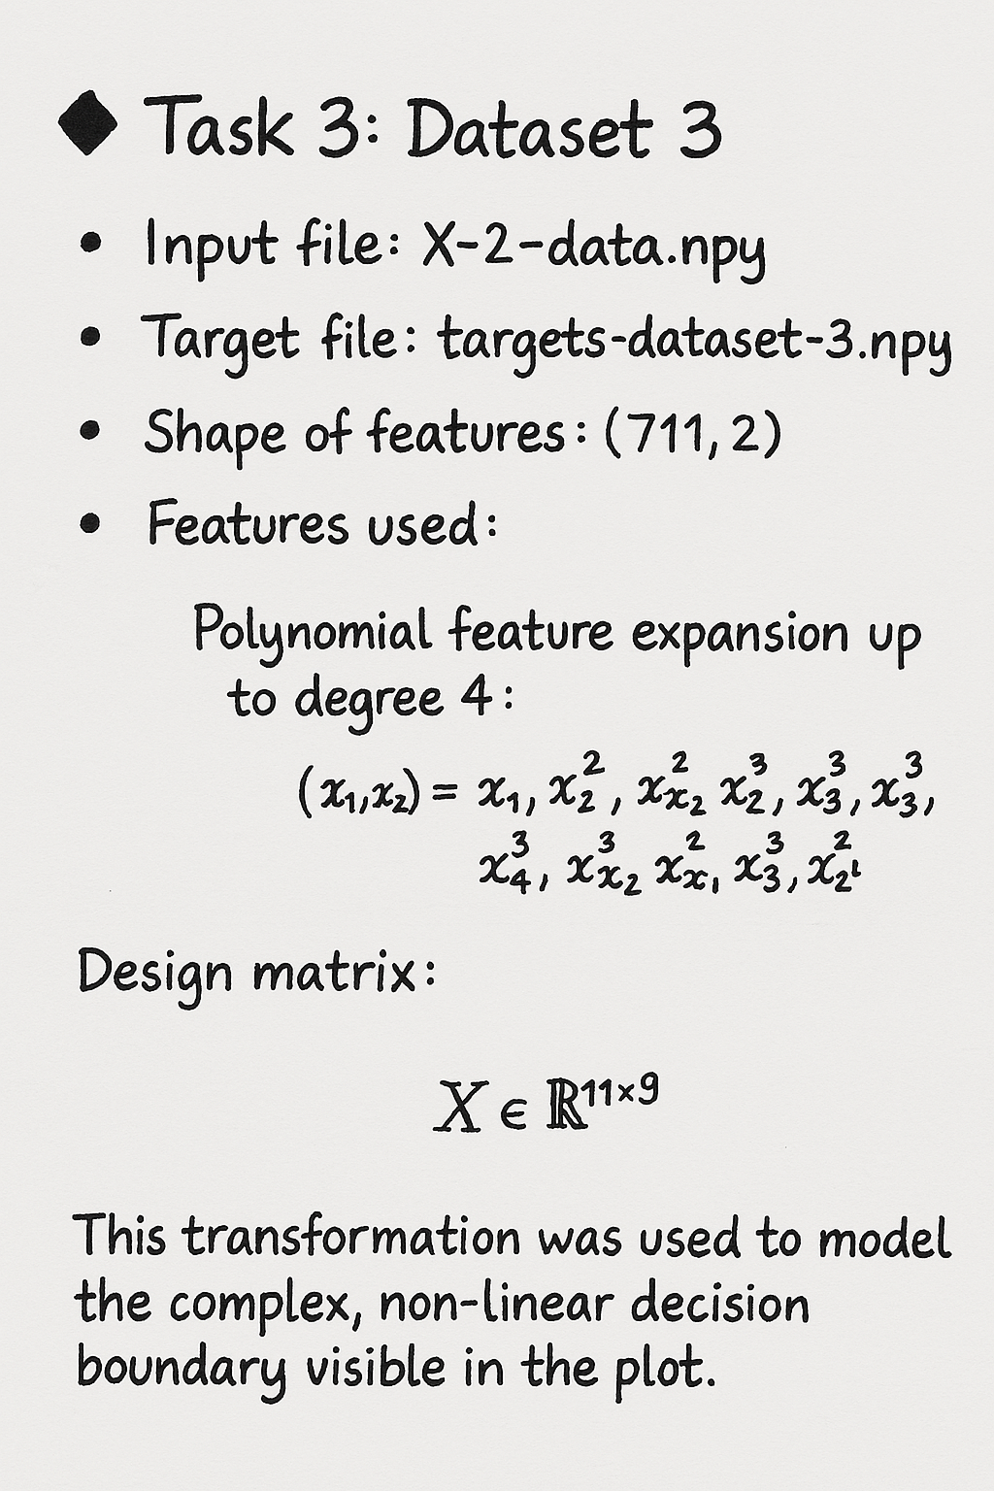

2.3: Training and Evaluation of Logistic Regression Models:

ask 1: Dataset 1

Penalty used: 'l2' (default)  
  
Features used: [x1, x2]  
  
Train accuracy: 83.21%  
  
Test accuracy: 85.83%  
  
Train loss: 0.3261  
  
Test loss: 0.3086  
Task 2: Dataset 2

Penalty used: 'l2'

Features used: Polynomial: [x1, x2, x1·x2, x1², x2²]

Train accuracy: 100.00%

Test accuracy: 100.00%

Train loss: 0.0005

Test loss: 0.0006

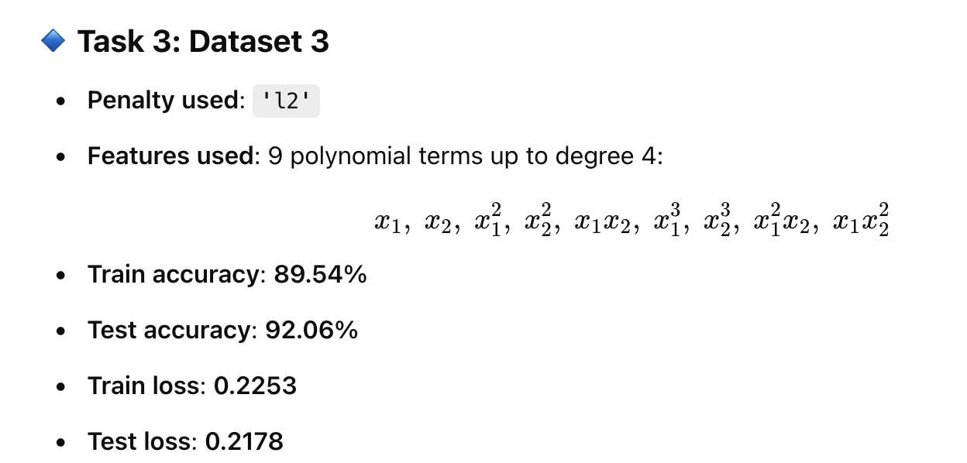

2.4: 6 plots

plots:

logreg_train1

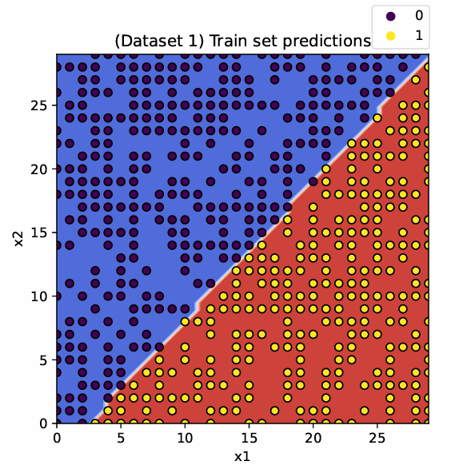

logreg_test1

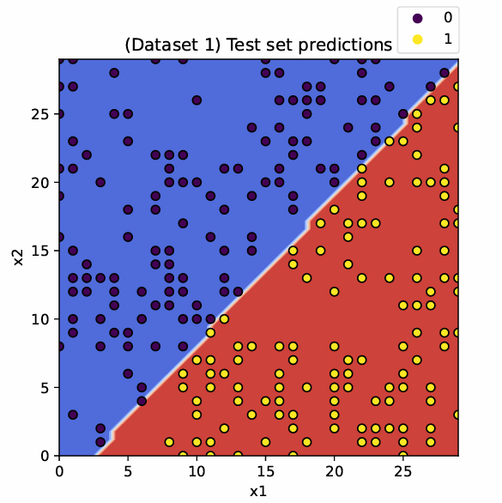

logreg_train2

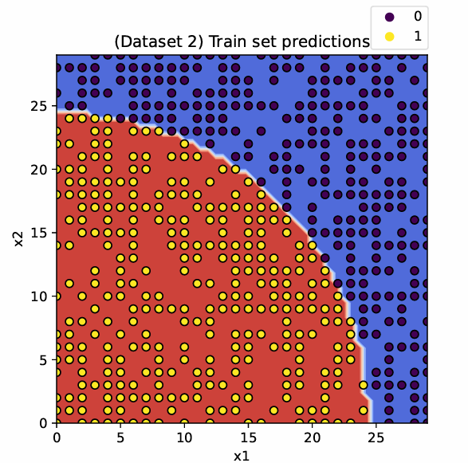

logreg_test2

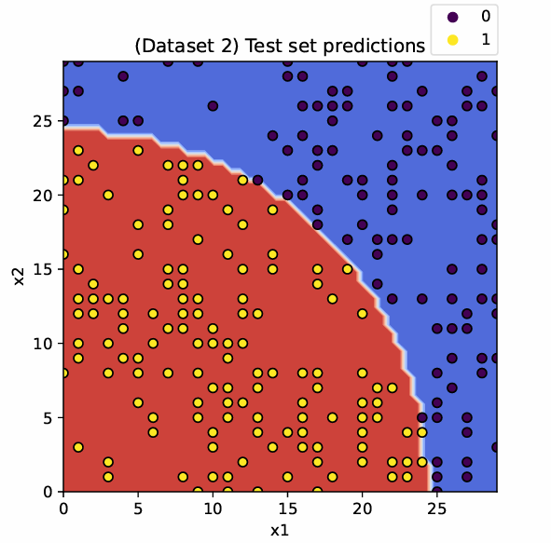

logreg_train3

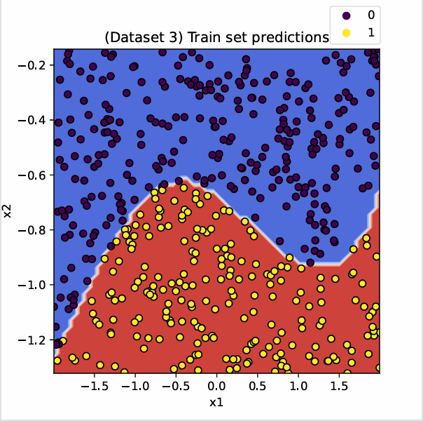

logreg_test3

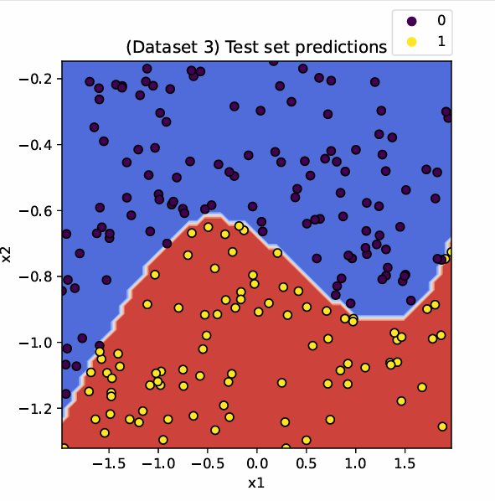

2.5: Model Parameters:

Dataset 1

Weights:

w=[0.2777, −0.2565]

Bias (intercept): b=−0.6903

Dataset 2

Weights (with polynomial features):

w=[0.0023, −0.0274, 0.0221, −0.6561, −0.6541]

Bias (intercept):

b=388.6538

Dataset 3

Weights (with 9 polynomial features):

w=[−0.9517, −2.5718, 0.9212, −1.6395, 2.6100, 1.1819, −1.8647, −0.3714, −0.7053 ]

Bias (intercept):

b=−3.4731

2.6: Does 100% Accuracy Imply Zero Cross-Entropy Loss?

The statement is not correct.

The model may classify all samples correctly but still incur positive loss if its predicted probabilities are not perfectly confident.

Explanation:

Accuracy measures whether the predicted class labels match the true labels.

Cross-entropy loss, however, also takes into account the confidence of the predictions. It penalizes predictions that are correct but made with low confidence.

For example, if the true label is 1 and the model predicts a probability of 0.51 for class 1 (i.e., it is just slightly above the decision threshold), the prediction is correct, but the loss is still non-zero.

In contrast, the cross-entropy loss becomes 0 only if the model assigns a probability of exactly 1 to the correct class and 0 to the incorrect class for every sample — which is rare in practice.

3.3: Gradient Descent on the Rastrigin Function

We are given the Rastrigin function

f(x,y) = 20+x2+y2+10cos(2πx)-1-cos**(2πy)**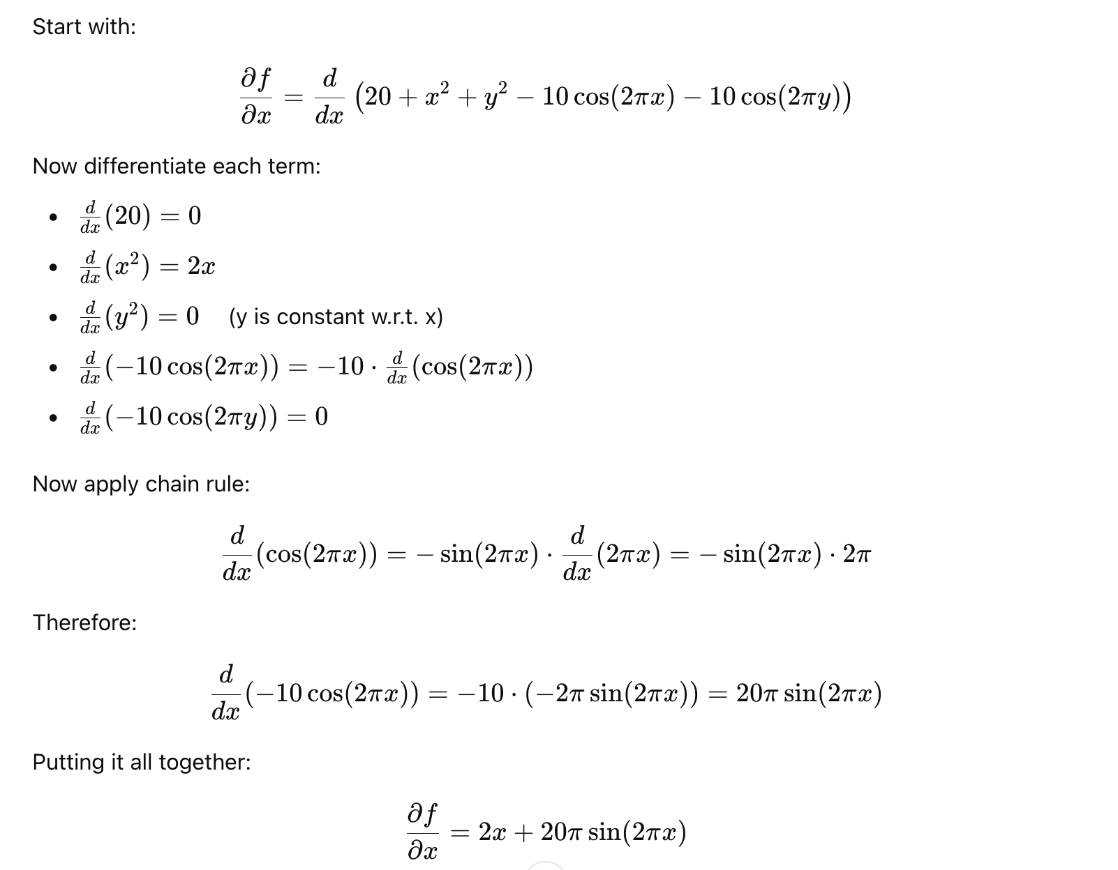

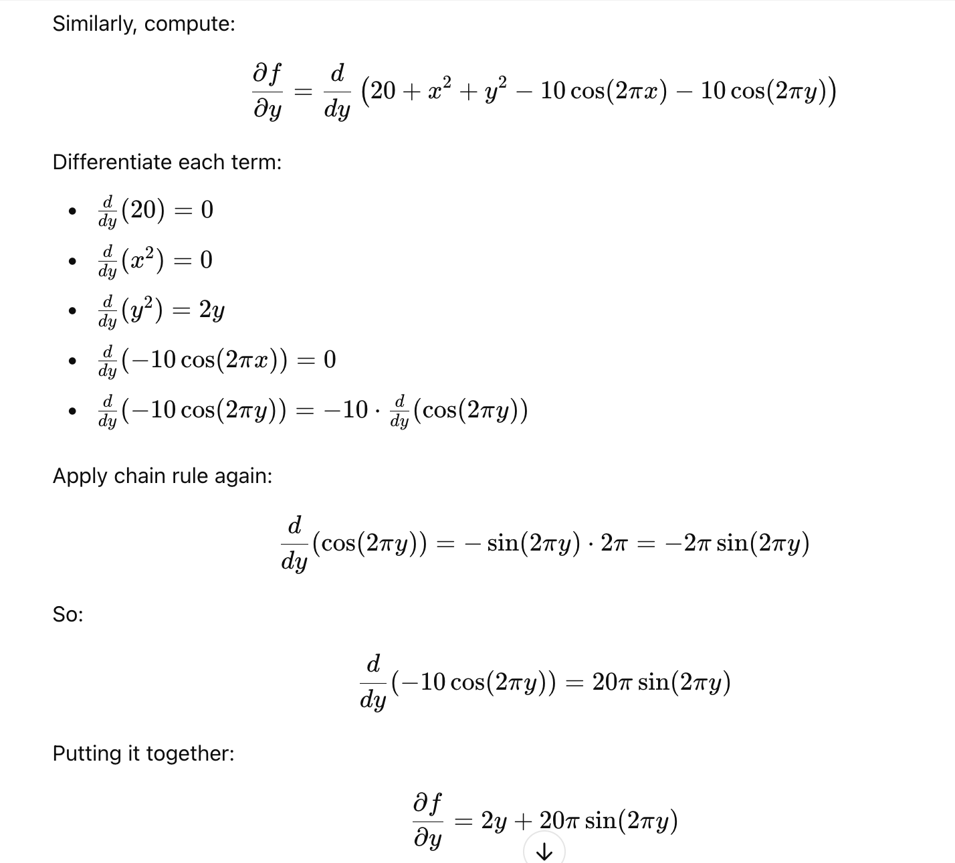

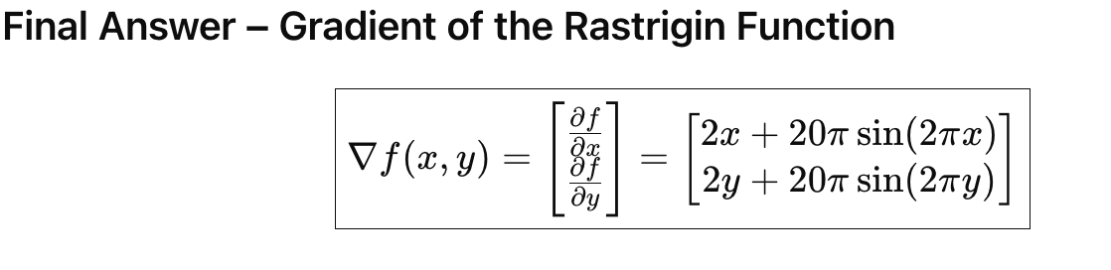

3.5: Finite Difference Approximation of the Gradient:

Defination of partial derivation

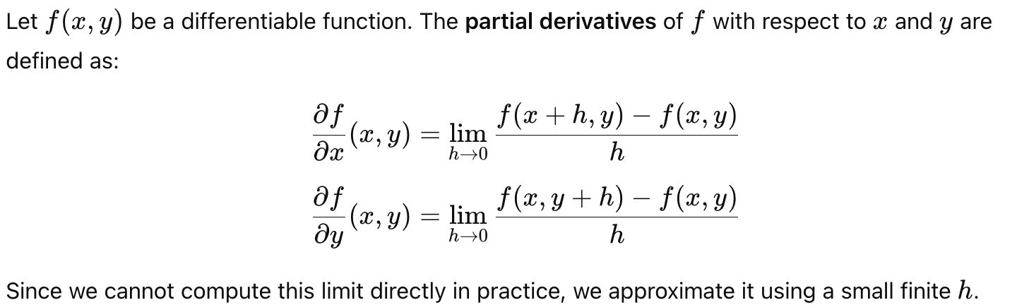

Finite difference approximation

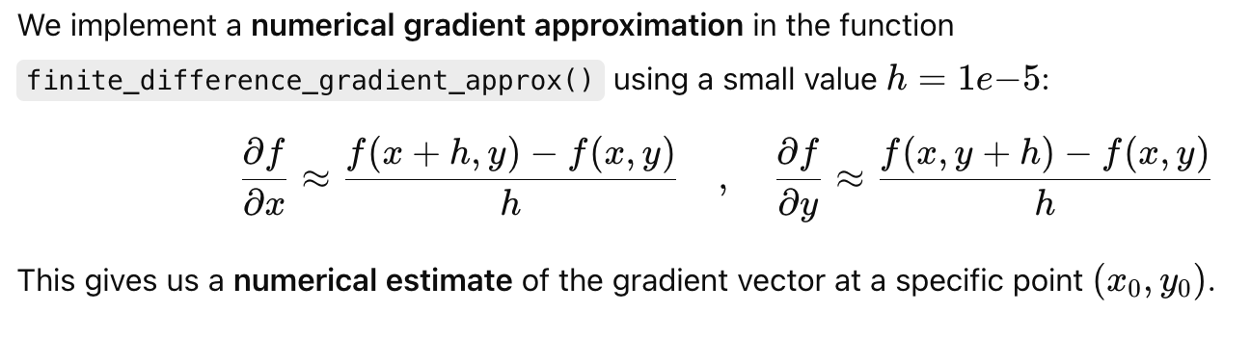

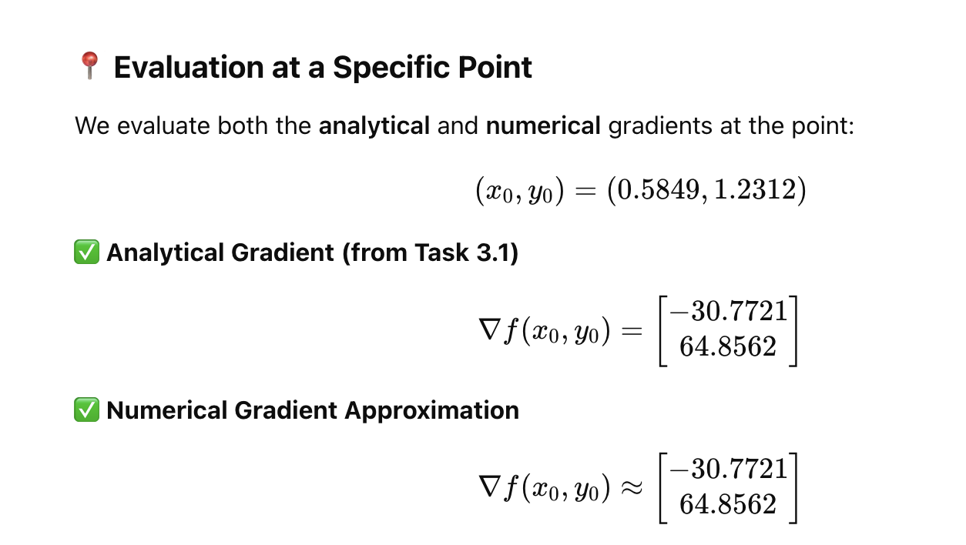

Comment on the Quality of Approximation

The numerical gradient closely matches the analytical gradient at the evaluated point. The results show very high agreement up to 4–5 decimal places.

This confirms:

Our pen-and-paper gradient computation is correct, and

The finite difference approximation is reliable for sufficiently small values of h

3.6: Why is the Rastrigin Function Challenging to Optimize?

From the contour plot and the optimization trajectory (see 2d_contour.pdf and function_over_iterations.pdf):

The surface of the function is highly non-convex

It contains many local minima and maxima due to the periodic cosine terms

The optimization trajectory shows the algorithm struggling to converge smoothly and taking oscillatory paths as it descends

Why It’s Challenging:

-Multiple Local Minima:

The cosine terms introduce a large number of equally spaced "valleys" and "ridges"

Gradient descent can easily get stuck in a local minimum that is far from the global minimum at (0,0)

-Oscillatory Gradient Surface:

The gradients vary rapidly due to the sinusoidal components  
  
This makes the step directions unstable and noisy, especially if the learning rate is not tuned carefully

-Flat Regions Near Minima:

Even when approaching the global minimum, the gradients become small  
  
This can result in slow convergence and the risk of stopping prematurely

to sum up:

The Rastrigin function is difficult to optimize due to its highly non-convex, multi-modal landscape and oscillatory gradient structure.

Even though gradient descent may eventually find a good local minimum, finding the global minimum is non-trivial and requires careful tuning of hyperparameters like the learning rate or using more advanced optimization methods (e.g., momentum, stochasticity, or global search heuristics).  
  
3.7: Gradient Descent Minimization of the Rastrigin Function:

We apply the gradient descent algorithm using the true analytical gradient (not the finite difference approximation) to minimize the Rastrigin function:

f(x,y)=20+x2+y2−10(cos(2πx)+cos(2πy))

The following hyperparameters were used:

Initial point:

(x0,y0)=(0.5849, 1.2312)

Learning rate (ηη):

η0=0.01

Learning rate decay:

Exponential decay: ηt=η0⋅γt, with γ=0.99

Number of iterations:

T=1000

From Task 3.3, the gradient of the Rastrigin function is:

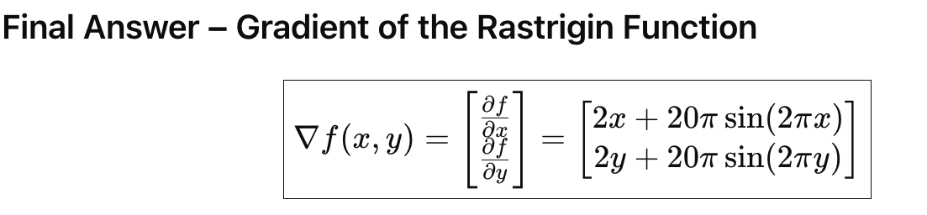

Optimization Results

Final point reached:

(x∗,y∗)≈(5.8293, 4.8714)

Function value at this point:

f(x∗,y∗)=66.0243

Global minimum:

f(0,0)=0.0000

Although the algorithm did not find the global minimum, it reached a good local minimum with relatively low function value.

3.8: Contour Plot and Gradient Descent Trajectory: 2d_contour.pdf

Commentary:

The trajectory reveals the non-convex nature of the Rastrigin function.

The algorithm does not follow a direct path to the global minimum due to the multiple local minima and oscillations in the function landscape.

The path includes several small, irregular steps — especially early on — where the algorithm adjusts to the steep gradients and periodic curvature of the function.

Eventually, the updates settle into a local minimum, as seen by the convergence near a stable point on the plot.

3.9: Function Value Over Gradient Descent Iterations plot:

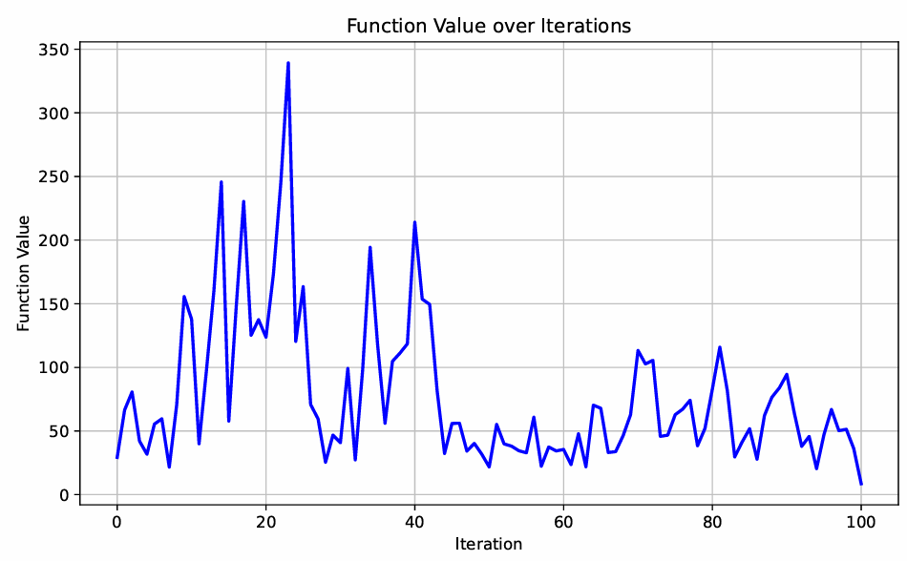

3.10: The Role of Learning Rate Decay in Optimizing the Rastrigin Function:

Setting the learning rate decay to 1.0 means:

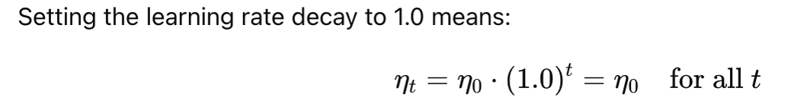

This means the learning rate stays constant throughout all iterations.

Observed Behavior:

The optimization becomes unstable, especially in regions with steep or oscillatory gradients.

The algorithm may overshoot minima, oscillate, or get trapped in poor local minima.

The function value might fluctuate or stagnate, preventing smooth convergence.

Why Decaying the Learning Rate Helps:

The Rastrigin function is:

Non-convex, with many local minima

Full of oscillatory behavior due to the cosine terms

Using a decaying learning rate helps because:

Large steps early on allow the optimizer to explore the space and avoid shallow local minima.

Smaller steps later help the optimizer to settle into precise local minima without overshooting or oscillating.

It balances exploration and convergence — enabling escape from noise initially and fine-tuning near the end.